Join the ‘Movement’ for ‘Movement’

Help Iowa Lead the way with Active People – Healthy Nation!
A collaborative vision of the Iowa State University (ISU) – Community Connections for Public Health (CCPH) Group
Vision: Promoting physical activity in Iowans through community-campus partnerships

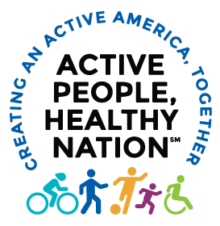
Background and Goals
The Centers for Disease Control and Prevention has launched the “Active People – Healthy Nation’ campaign to promote physical activity and healthy living in the country. The goal is to help 27 million Americans to become active by 2027. The ISU Community Connections for Public Health (CCPH) group is committed to helping Iowa to be a leader in the campaign by helping to support more effective partnerships. The goal is to support county and local organizations in efforts to promote the campaign.
- Primary Goals (Organizational Support)
The primary goal is to directly foster awareness of the campaign and to share resources and strategies developed through the National Physical Activity Plan to support Iowa organization
  - Increase awareness of the Active People-Healthy Nation program by professionals and organizations in the state of Iowa
  - Increase promotion of the Active People-Healthy Nation message by state, county and local agencies using strategies in the National Activity Plan

Secondary Goal (Individual Impact)
The secondary goal is to indirectly support messaging and awareness in Iowans through more effective campus-community partnerships.
  - Increase awareness of the importance of physical activity for health and well-being by residents of Iowa
  - Increase engagement in physical activity through enhanced community-based programming and messaging to residents of Iowa

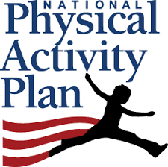
Methods, Plans and Needs
The ISU Community Connections for Public Health (CCPH) group is positioned to help create partnerships needed to make progress on the national Active People Healthy Nation campaign. Resources and methods have already been developed and outlined by the Physical Activity Alliance - https://paamovewithus.org/ which developed the National Physical Activity Plan. Thus, the primary methods are to facilitate sharing and operationalization of the methods and strategies in the national plan within Iowa. We envision a broad, sustainable and collaborative model that would work in harmony with other ongoing state initiatives and partnerships to help promote physical activity in Iowa. We are seeking interest and conceptual endorsements from public health organizations and agencies across the state to build some momentum for this effort. Please contact us at CCPH@iastate.edu or visit our website at https://www.ccph.iastate.edu/ to learn more and to join the movement.

